Chapter 5 Chemical reactions
extra worksheet 3: Reaction rate and concentration
Science Understanding Logical/Mathematical
Hasan and Harriet decided to perform an experiment to test the hypothesis:
‘Doubling the concentration of an acid will double the rate of reaction.’

To test their hypothesis, Hasan and Harriet examined the reaction between hydrochloric acid and magnesium metal, using the apparatus shown in Figure 1. This reaction produces hydrogen gas and magnesium chloride.
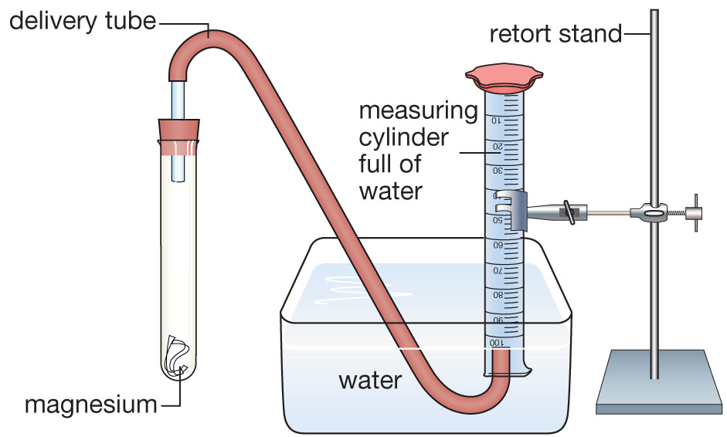
Figure 1
Firstly, they combined dilute hydrochloric acid with a strip of magnesium ribbon in a large test tube. The large test tube had a rubber stopper with a tube inserted. The tube ran into an inverted measuring cylinder that was full with water. The amount of hydrogen produced by the reaction could then be measured as it bubbled into the measuring cylinder and displaced the water.

The same procedure was then used the measure the amount of hydrogen produced when concentrated hydrochloric acid was used.

The results are summarised in the table on the next page.
Time (mins) | Volume of hydrogen produced (mL) for dilute acid | Volume of hydrogen produced (mL) for concentrated acid
0.0 | 0 | 0
0.5 | 4 | 6
1.0 | 8 | 12
1.5 | 11 | 16
2.0 | 14 | 20
2.5 | 16 | 20
3.0 | 19 | 20
3.5 | 20 | 20
4.0 | 20 | 20
4.5 | 20 | 20
5.0 | 20 | 20

Questions
1 Write the word equation and formula equation for the chemical reaction examined in this experiment.
a Word equation
b Formula equation
2 Identify what variables should have been kept constant by Hasan and Harriet during the experiment.

3 Use the data to draw a line graph on the axes provided. You should have two lines, one for dilute acid and one for concentrated acid. Don’t forget to include a key.
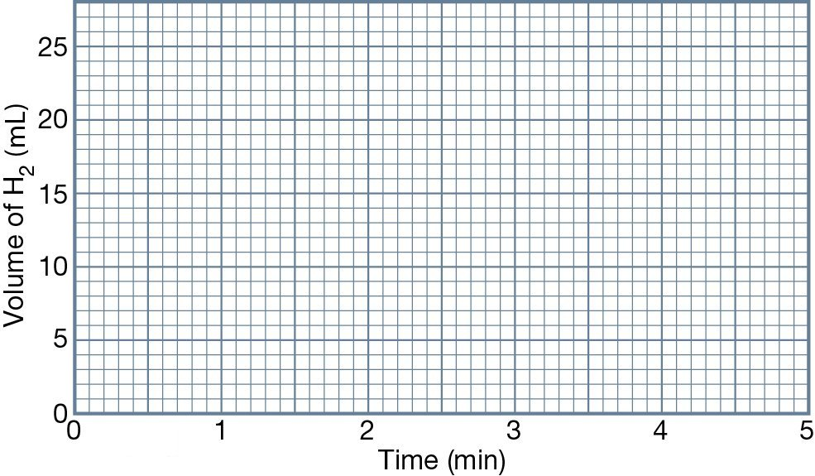
4 a Describe any trends you observe in the data.

b Compare the data from the dilute and concentrated acids.

5 a Was the hypothesis of Hasan and Harriet correct?

b Use the data to justify your answer.

6 a Draw particle model diagrams to show why there is a difference in the rates of reaction for the dilute and concentrated acids.

Dilute hydrochloric acid | Concentrated hydrochloric acid
b Describe how concentration affects the rate of reaction.

